Student exercise 5

***This exercise to be done by the student in class***

1. Take class exercise four (4) into consideration and change the code for a user to add his/her own data,

Output should be as follow:

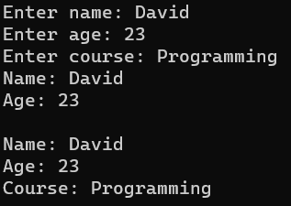

1. Take class exercise five (5) into consideration and change the code for a user to add his/her own data,

Output should be as follow:

